## 1. Provide the list of markets in which customer "Atliq Exclusive"

## operates its business in the APAC region.

SELECT Market, Customer, region from dim_customer where customer = "atliq Exclusive"

and region = "apac";

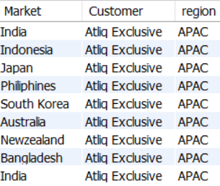

## 2.What is the percentage of unique product increase in 2021 vs. 2020? The final output contains these fields,

## unique_products_2020 unique_products_2021 percentage_chg

Select * from fact_sales_monthly;

with Unique_products_2020 as (

Select count(distinct product) as dis2020 from dim_product dp

join fact_sales_monthly fsm on dp.product_code = fsm.product_code

where fiscal_year = 2020),

Unique_products_2021 as (Select count(distinct product) as dis2021 from dim_product dp

join fact_sales_monthly fsm on dp.product_code = fsm.product_code

where fiscal_year = 2021)

Select dis2020,dis2021,

Round((dis2021 - dis2020)/dis2020*100,2) as percentage_chg from

Unique_products_2020,Unique_products_2021;



## 3 Provide a report with all the unique product counts for each segment and

## sort them in descending order of product counts. The final output contains 2 fields

## segment, product_count

Select segment, count(distinct product) as product_count from dim_product dp

join fact_sales_monthly fsm on dp.product_code = fsm.product_code group by segment;

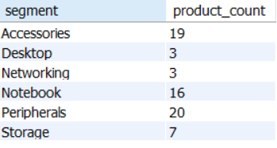

## 4 Follow-up: Which segment had the most increase in unique products in

## 2021 vs 2020? The final output contains these fields,segment, product_count_2020, product_count_2021,difference

WITH Unique_products_2020 AS (

SELECT

segment,

COUNT(DISTINCT product) AS product_count_2020

FROM

dim_product dp

JOIN

fact_sales_monthly fsm

ON

dp.product_code = fsm.product_code

WHERE

fiscal_year = 2020

GROUP BY

segment

),

Unique_products_2021 AS (

SELECT

segment,

COUNT(DISTINCT product) AS product_count_2021

FROM

dim_product dp

JOIN

fact_sales_monthly fsm

ON

dp.product_code = fsm.product_code

WHERE

fiscal_year = 2021

GROUP BY

segment

)

SELECT

u2020.segment,

u2020.product_count_2020,

u2021.product_count_2021,

(u2021.product_count_2021 - u2020.product_count_2020) AS difference

FROM

Unique_products_2020 u2020

JOIN

Unique_products_2021 u2021

ON

u2020.segment = u2021.segment

ORDER BY

difference DESC;

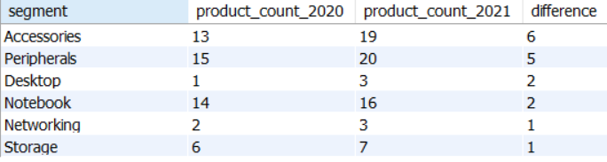

## 5 Get the products that have the highest and lowest manufacturing costs.

## The final output should contain these fields,

## product_code, product, manufacturing_cost

with x as (Select product,dp.product_code,manufacturing_cost from dim_product DP join

fact_manufacturing_cost FMC on DP.Product_code = fmc.Product_code

order by manufacturing_cost desc limit 1),

y as (Select product,dp.product_code,manufacturing_cost from dim_product DP join

fact_manufacturing_cost FMC on DP.Product_code = fmc.Product_code

order by manufacturing_cost asc limit 1)

select * from x union select * from y;

WITH ranked_products AS (

SELECT

product,

dp.product_code,

manufacturing_cost,

RANK() OVER (ORDER BY manufacturing_cost ASC) AS rank_asc,

RANK() OVER (ORDER BY manufacturing_cost DESC) AS rank_desc

FROM dim_product DP

JOIN fact_manufacturing_cost FMC

ON DP.product_code = FMC.product_code

)

SELECT

product,

product_code,

manufacturing_cost

FROM ranked_products

WHERE rank_asc = 1 OR rank_desc = 1;

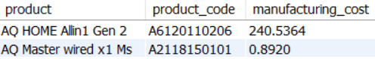

## 6 Generate a report which contains the top 5 customers who received an

##average high pre_invoice_discount_pct for the fiscal year 2021 and in the

##Indian market. The final output contains these fields,

## customer_code, customer,average_discount_percentage

SELECT

fsm.customer_code,

customer,

AVG(pre_invoice_discount_pct) AS average_discount_percentage

FROM

fact_pre_invoice_deductions FPID

JOIN

dim_customer dC ON fpid.customer_code = dc.customer_code

JOIN

fact_sales_monthly fsm ON dc.customer_code = fsm.customer_code

WHERE

fsm.fiscal_year = 2021

AND market = 'india'

GROUP BY fsm.customer_code , customer

ORDER BY average_discount_percentage DESC

LIMIT 5;

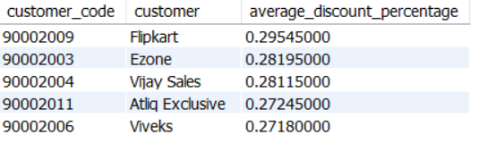

## 7 Get the complete report of the Gross sales amount for the customer “Atliq

## Exclusive” for each month. This analysis helps to get an idea of low and

## high-performing months and take strategic decisions.

## The final report contains these columns:

## Month, Year, Gross sales Amount.

with x as (SELECT

MONTH(date) AS month,

YEAR(date) AS year,

ROUND((gross_price * Sold_quantity), 2) AS total_sales

FROM

fact_gross_price fgp

JOIN

fact_sales_monthly fsm ON fgp.product_code = fsm.product_code

JOIN

dim_customer dm ON fsm.customer_code = dm.customer_code

WHERE

customer = 'Atliq Exclusive')

SELECT

month, year, SUM(total_sales) AS gross_sales_amount

FROM

x

GROUP BY month , year

ORDER BY year ASC, month asc;

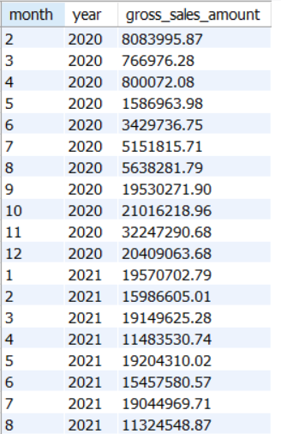

## 8 In which quarter of 2020, got the maximum total_sold_quantity? The final

## output contains these fields sorted by the total_sold_quantity,

## Quarter, total_sold_quantity

SELECT

YEAR(date) AS year,

QUARTER(date) AS quarter,

SUM(Sold_quantity) AS total_sold_quantity

FROM

fact_sales_monthly

WHERE

YEAR(date) = 2020

GROUP BY YEAR(date) , QUARTER(date)

ORDER BY total_sold_quantity DESC

LIMIT 1;



## 9 Which channel helped to bring more gross sales in the fiscal year 2021

## and the percentage of contribution? The final output contains these fields,

## channel , gross_sales_mln, percentage

WITH x AS (

SELECT

dm.channel,

SUM(ROUND(gross_price * Sold_quantity, 2)) AS channel_sales

FROM

fact_gross_price fgp

JOIN

fact_sales_monthly fsm ON fgp.product_code = fsm.product_code

JOIN

dim_customer dm ON fsm.customer_code = dm.customer_code

WHERE

fsm.fiscal_year = 2021

GROUP BY

dm.channel

),

y AS (

SELECT

SUM(channel_sales) AS total_sales

FROM

x

)

SELECT

x.channel,

ROUND((x.channel_sales / y.total_sales) * 100, 2) AS percentage

FROM

x, y

ORDER BY

percentage DESC;

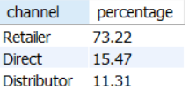

## 10. Get the Top 3 products in each division that have a high

## total_sold_quantity in the fiscal_year 2021? The final output contains these

## fields,division, product_code, product, total_sold_quantity, rank_order

WITH RankedProducts AS (

SELECT

division,

dp.product_code,

dp.product,

SUM(fsm.sold_quantity) AS total_sold_quantity,

RANK() OVER (PARTITION BY division ORDER BY SUM(fsm.sold_quantity) DESC) AS rank_order

FROM

dim_product dp

JOIN

fact_sales_monthly fsm

ON

dp.product_code = fsm.product_code

WHERE

fsm.fiscal_year = 2021

GROUP BY

division, dp.product_code, dp.product

)

SELECT

*

FROM

RankedProducts

WHERE

rank_order <= 3

ORDER BY

division, rank_order;

